SDEP Introduction

1. SDEP Introduction 10-11-12

1.1 Title
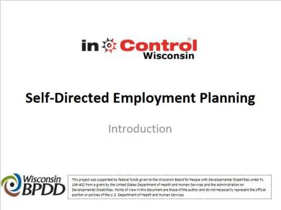
Notes:
Welcome to the Self-Directed Employment Planning Training. This training was developed by Shannon Munn-Huff and Nancy Farnon-Molfenter through inControl Wisconsin with funding made available from the Wisconsin Board for People with Developmental Disabilities.

This training was designed to help people with disabilities think about their integrated employment options, understand employment supports, and create a plan to achieve their integrated employment goals.

1.2 Purpose of this Training
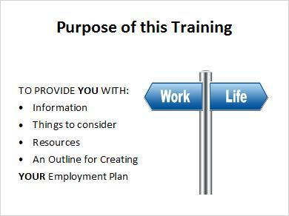
Notes:
The purpose of this training is to provide job seekers with disabilities and those who support them with information about ways to become employed, factors to consider, and resources available.

This training is called the Self-Directed Employment Planning training because it is very important for you to be involved in all of the decisions that are about you and your life.

Work is a part of life for most adults and having a disability does not mean that you cannot work. In fact, the authors and sponsors of this training believe that everyone can work, regardless of disability. We hope that this training will be helpful to you on your path to employment.

1.3 Self-Direction
Notes:
Self-direction, or self-determination, means that you make your own decisions using the resources that are available and with help from people you trust. It also means that you take responsibility by putting in the time and effort needed to get what you want. Taking the time to go through this training and put together your employment plan is one way you are taking responsibility in your life.

As one parent who reviewed this training indicated “Self-Determination is about freedom on how you want to live your life; having authority, being involved in decision making, getting support to organize resources, responsibility and self-advocacy.”

1.4 Achieving Success
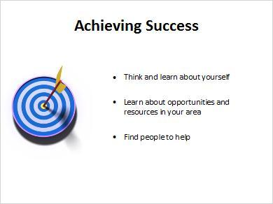
Notes:
To be as successful as possible at work, you will need to think about what you want to do, what you like to do, and what you are good at doing. You may know exactly what you want to do for work or you may be unsure and will need to try different things to figure out what type of work is right for you.

You may need to figure out what resources are available to you and what the employment options are in the area where you live. You may need to get additional education or training to get the type of job you want. You may want to consider starting your own business. You may be able to seek, obtain, and learn a job without a great deal of help from other people or you may need assistance with some or all of the steps involved in finding a job or starting a business.

We are all different, and the key, as we will discuss throughout the training, is knowing about yourself, making a plan that can meet your goals and needs, and then having the right help to be employed.

1.5 About the Training
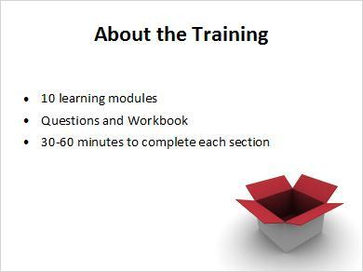
Notes:
This training has 10 content modules. You are in the Introduction now and there are 10 more after this. There is also a Conclusion Module to help you review and complete your employment plan.

There is a workbook that goes with this training. The workbook can be downloaded by selecting 'Resources' in the top right corner of this training. Each module has a corresponding section in the workbook. At the end of each module, there will be questions for you to answer. These questions are also in the workbook. If you use the workbook to answer the questions at the end of each module, then you will have the information you need for a written employment plan when you are done.

Each section of this training will take most people 30 to 60 minutes to complete if you watch each module and complete the workbook sections. It is ok if sections take you less or more time. You can do the training one section at a time or you can do as many sections in one sitting as you would like to do. There is no right or wrong way to do them. You can go back to them as many times as you want to. Do whatever is most helpful to you.

1.6 Modules 1-5
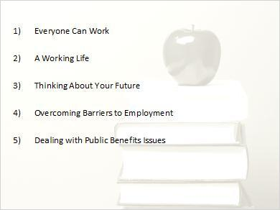
Notes:
The titles of the 10 modules in the Self-Directed Employment Planning training are:
One: Everyone Can Work
Two: A Working Life
Three: Thinking About Your Future
Four: Overcoming Barriers to Employment
Five: Dealing with Public Benefits Issues When You Work

1.7 Modules 6-10
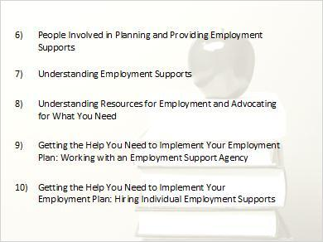
Notes:
Six: People Involved in Planning and Providing Employment Supports
Seven: Understanding Employment Supports
Eight: Understanding Resources for Employment and Advocating for What You Need
Nine: Getting the Help You Need to Implement Your Employment Plan: Working with an Employment Support Agency
Ten: Getting the Help You Need to Implement Your Employment Plan: Hiring Individual Employment Supports.
And, the Conclusion Module

1.8 Conclusion
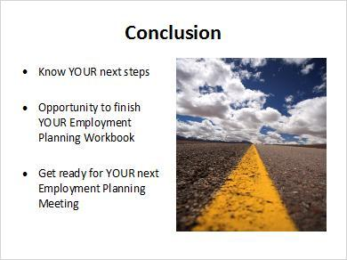
Notes:
After you complete the 10 sections of this training, you will have the chance to view a module that highlights the main points as a kind of review. The Conclusion Module will also walk you through the information in the Workbook that goes with this training.

If you get to the Conclusion with your Workbook filled out, the last Module will give you a chance to think about all of your answers and make sure they are what you want in your plan.

If you get to the Conclusion Module and have not yet answered the questions in the Workbook, you can fill in information as you go through that last module.

Either way, you can have a Plan for Employment created when you finish this training.

1.9 inControl Wisconsin website
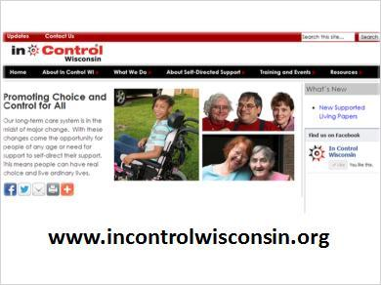
Notes:
A list of the 10 modules and the description of what is covered in each module can be found on the Self-Directed Employment Planning training web page on the inControl Wisconsin website. To view a module, click on its title.

The modules were created to be viewed one after the other in the order listed. The information from one module is built on or expanded in the next module. Viewing the modules in order will help you learn the material and build your employment plan. However, you can skip modules or view the modules in the order of most interest to you.

1.10 Download the Training Materials
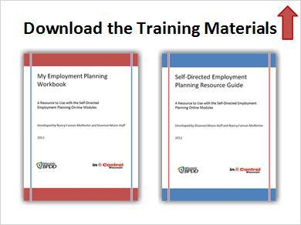
Notes:
Before starting the modules, download the Self-Directed Employment Planning Workbook. This workbook can be downloaded by selecting 'Resources' in the top right corner of this training. Remember, there will be questions at the end of each module. Those questions are also listed in the Workbook. If you write down your answers to these questions, you will have information to complete your Employment Plan when you get to the end of this training and the Workbook. There is also a full written narrative that goes with each module that can be found under 'Resources' in case you want to print those.

In addition to the training modules, Workbook and narratives, there is a Resource Guide to help you look up information as you go along. The Resource Guide can also be downloaded by selecting 'Resources' in the top right hand corner of this training.

1.11 Ready, Set, Action!
Notes:
You are now ready to begin the Self-Directed Employment Planning Training. Go at your own pace. You can go back to information as many times as you want to.

1.12 Tutorial Instructions
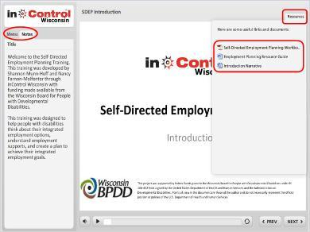
Notes:
Before we begin we would like to share some helpful hints to view this training. On the left side you will see tabs for the Menu and Notes. The Menu tab shows the slide names so you can find specific sections of the training. The Notes tab has all the written words of what is being said on the slides. If the narration is too long a scroll bar will appear so you can scroll down and follow along with the narration.

At the bottom you will see buttons for volume and a slide bar to move through the slide. The Previous and Next buttons will move you through the slides if you are wanting to skip through. On the top you will see the title of the training. On the top right you will see Resources. When Resources is selected you will be able to find an Employment Planning Workbook, Resource Guide and the narration for that training. These will be referenced throughout the different training modules. You can open and save any of these documents to your computer at any time.

