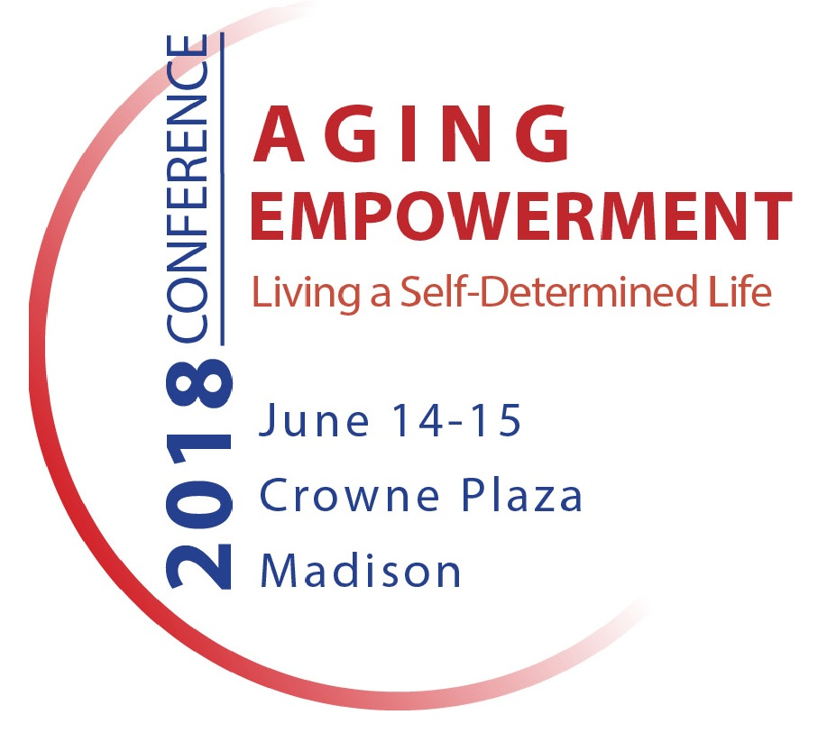

Call for Presentations

ABOUT THIS EVENT: The 2018 Aging Empowerment Conference: Living a Self-Determined Life focuses on exploring how to ensure we are seizing opportunities that impact both policy and community efforts to preserve full citizenship far into the later years of life. This is the 5th annual conference and is hosted by InControl Wisconsin and other sponsors.

DATE AND LOCATION: June 14-15, 2018, at the Crowne Plaza Hotel and Conference Center, Madison, WI.

LEARNING OBJECTIVES:
- Challenge traditional ways of thinking about aging and older adults and explore how older people can retain control and choice
- Give voice to older people’s desire and capacity to maintain control of their lives – including people with dementia
- Promote the exchange of information on self-determination between older adults, family members, and professional caregivers
- Explore how individuals, agencies, and organizations can collaborate to design programs and services that allow opportunity for self-determination
- Identify effective ways to support and empower family caregivers

AUDIENCE: The conference attracts a diverse statewide audience that includes older adults, caregivers, and professionals. In addition to direct care workers, professionals who attend include staff from county and tribal aging offices and Aging & Disability Resource Centers (ADRCs), State Office on Aging and Office for Resource Center Development, IRIS Independent Consultant Agency Providers, IRIS Fiscal Employer Agent Providers, Independent Living Centers, human services departments, advocacy organizations, managed care organizations, adult protective service agencies, crisis and mental health agencies, agencies serving people with developmental disabilities, long-term care facilities, and health care providers.

FORMAT: Each conference workshop is 1 hour in length. Workshops requiring more time may utilize two sessions.

TOPIC IDEAS: Subject areas are identified below. Suggested topics are listed to give an idea of the topic area, not to limit or define submissions, and other ideas are welcome.

SELECTION PROCESS: All proposals are reviewed by the conference planning committee. Notifications will be made by April 1, 2018.

TO SUBMIT A PROPOSAL
- To submit a proposal, click here or visit: https://www.surveymonkey.com/r/DHQ6DZX
- Proposals must be received by March 15, 2018.
- Questions? Contact Peggy Rynearson, Conference Planner, at prynearson@gmail.com.

TOPIC AREA: Self-Determination in Caregiving
Description: Older adults often depend on family or professional caregivers to provide necessary supports, but wish to maintain the ability to make independent decisions. Fostering positive relationships between caregiver and older adult is necessary in order for the older adult to maintain as much control as possible. Additionally, agencies and direct care workers need training and support to understand how they can deliver care in a manner that supports self-determination.
Suggested topics include:
- Recruiting, training and supporting direct care workers who value self-determination
- Maintaining self-direction when using an agency based workforce
- Strategies to support people hiring care providers directly
- Empowering partnerships between family caregivers and older adults
- Sharing stories and experiences from older adults and family caregivers that support a self-determined life
- Juggling work and caregiving
TOPIC AREA: Self-Determination in Programs and Services
Description: Principles of self-determination can inform the development and implementation of programs and services that maintain choice and control as much as possible.
Suggested topics include:
- Self-determination reflected in Older Americans Act programs, including home and community based meals, transportation, and senior centers.
- Self-direction in long term care
- Veterans directed home and community based services
- County dementia support teams
- Myths that effect the delivery of services to older adults
- Person-centered planning that truly empowers the person
- Employment benefits counseling

TOPIC AREA: Self-Determination in Healthcare & Rehabilitation
Description: Approaching individualized healthcare and healthcare systems and hospitals from a perspective of self-determination illuminates many areas where maintaining control over one’s life can be achieved.
Suggested topics include:
- End of life issues
- Supporting self-determination throughout the dying process
- Increasing empowerment and self-direction in health care
- Strategies for preventing and minimizing harmful events occurring in hospital settings
- Supporting patients and caregivers during transitions
- Advance directives
- Models of self-determination in an integrated care model (long term care and health care provided in the same program)
- Enhancing self-determination in post-acute and rehab care
- Innovative treatments and/or approaches to rehab that support self-determination
- Grief counseling
TOPIC AREA: Livable Communities that Support
Self-Determination
Description: Self-determination has the best chance of becoming reality for the individual when communities develop infrastructure to support it. Communities that promote the development of safe, accessible, and vibrant environments are often called “livable communities.” Policies that address issues such as land use, housing, transportation, and broadband can be crafted to facilitate aging in place.
Suggested topics include:
- Building dementia friendly communities
- Dementia Café
- Creating neighborhoods that are inclusive, cooperative and engaged
- Asset Based Community Development
TOPIC AREA: Technology and Home Modifications that Support Self-Determination
Description: Staying in one’s home is the heart of aging in place, and self-determination can be realized with innovative in-home supports.
Suggested topics include:
- Innovative technology for self-determination
- Strategies to help older adults stay in their homes
- Home modification to support independence
- Tenant rights
TOPIC AREA: Self-Determination and Clinical Considerations
Description: Understanding specific needs and differences helps support self-determination for individuals with unique circumstances. Effective service delivery requires the capacity to provide support within the context of clinical considerations.
Suggested topics include:
- Dementia
- Developmental disabilities
- Physical disabilities
- Mental health
- Self-management of chronic conditions

TOPIC AREA: Self-Determination and Cultural Considerations
Description: Understanding the specific cultural, language, social and economic nuances of people and families provides a necessary perspective to support self-determination. Facilitating self-determination through the lens of cultural understanding creates both challenges and opportunities.
Suggested topics include:
- Communicating when speaking different languages
- Understanding and respecting cultural differences
- Unique strategies to promote self-determination in particular cultural contexts
- Person-centeredness within diverse cultures
TOPIC AREA: Self-Determination and Advocacy
Description: Learning the skills and techniques of advocating for the needs of self and others in a variety of settings is important to both older adults and caregivers. Systems change advocacy works to change government, organization and agency policies, rules and laws and is critical to fostering a culture of self-determination in aging.
Suggested topics may include:
- Self-advocacy
- Advocating as the family or professional caregiver
- Systems change advocacy
- Self-direction in long term care
- Maximizing decision making roles with guardianship, power of attorney and shared decision-making
- Self-determination in Wisconsin state policy
- Self-directed option in the plan for Wisconsin’s future long-term support system
- Combating ageism and the erosion of civil rights

